Name__________Ananda Lakshmi Shrestha______________ Mark _____________________/50

Brief introduction __/3
My contribution to the Retro Hockey game is the implementation and design of the menu screen. The game will be accessed through the menu screen. It will enable the player to access the Start Game, Save Game, Load Game, Instructions, and Exit sections of the game. The menu has to be responsive to keyboard and controller input, visually consistent with the game's vintage aesthetic, and easy to use. I am also in responsible of making sure that player options (such saving or loading a game) work properly and that the menu blends in smoothly with the game's main loop (gameplay screen).

Use case diagram with scenario __14

Use Case Diagram 1: Navigate Menu

Scenario 1 (UC1):
Name: Navigate Menu Options
Summary: The player interacts with the menu to select an option (e.g., Start Game, Save Game, Load Game, Instructions, Exit).
Actors: Player
Preconditions: Menu screen has been loaded after the game launches.
Basic Sequence:
Menu loads and displays available options.
Player uses keyboard/controller to scroll through options.
Player highlights a desired option.
Player confirms selection (Enter/Controller button).
Exceptions:
Step 2: Player provides no input (menu remains idle).
Step 4: Invalid input is given (ignored, menu stays active).
Postconditions: The selected option triggers its corresponding function (e.g., start game, save, load, exit).
Priority: 1

Use Case Diagram 2: Save and Load Game

Scenario 2 (UC2):
Name: Save/Load Game Functionality
Summary: Player selects Save Game or Load Game from the menu to store or retrieve their game progress.
Actors: Player, Game State System
Preconditions: Game progress exists for saving or a saved game file exists for loading.
Basic Sequence:
Player selects Save or Load Game from the menu.
System prompts confirmation (optional).
If Save is chosen, the current game state is stored.
If Load is chosen, the stored game state is retrieved and gameplay resumes.
Exceptions:
Step 3: No active game to save → display error.
Step 4: No save file found → display error.
Postconditions: The game state is successfully saved or restored.
Priority: 1

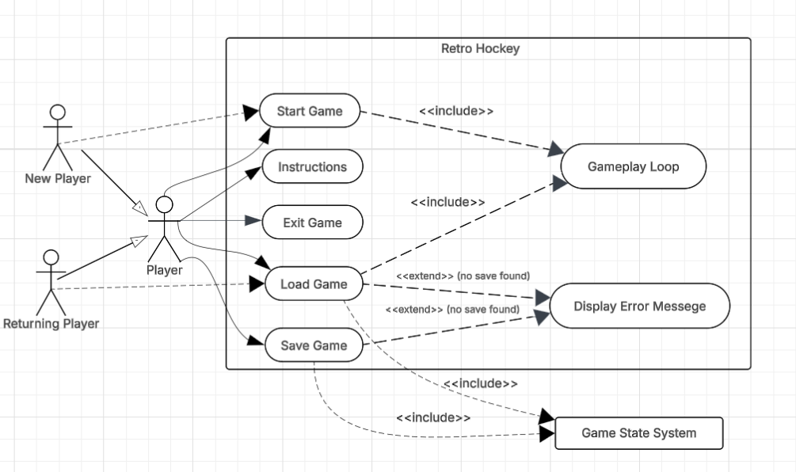

Data Flow diagram(s) from Level 0 to process description for your feature _______14

Data Flow Diagrams
Level 0 DFD-Menu Screen System
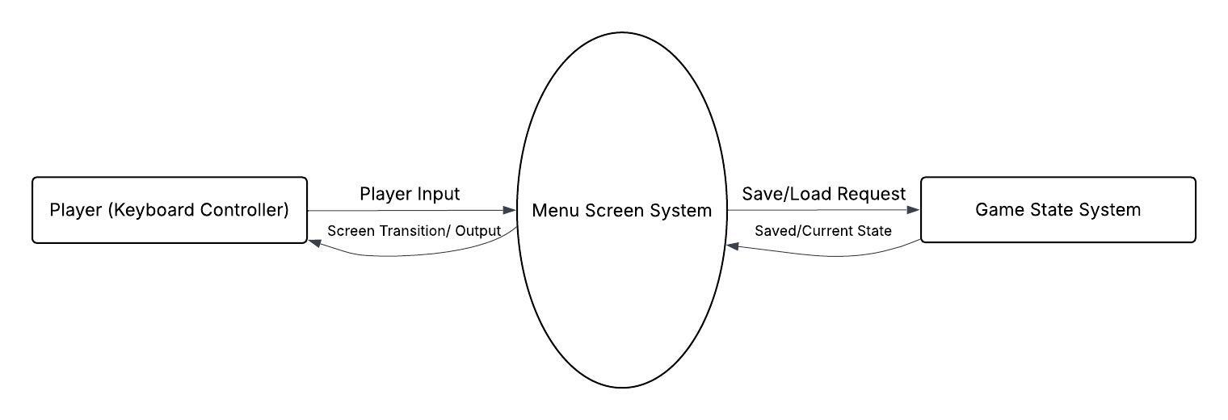
Level 1 DFD- Expandad Menu Screen Processes
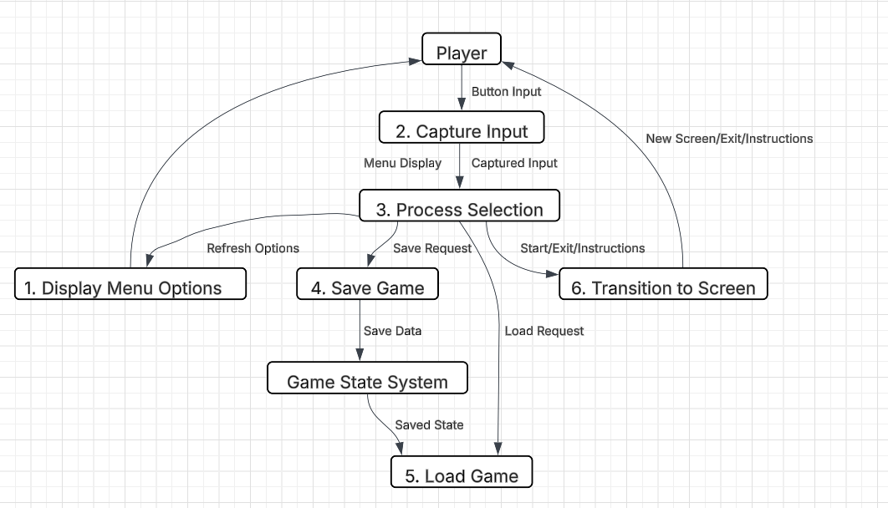

Process Descriptions
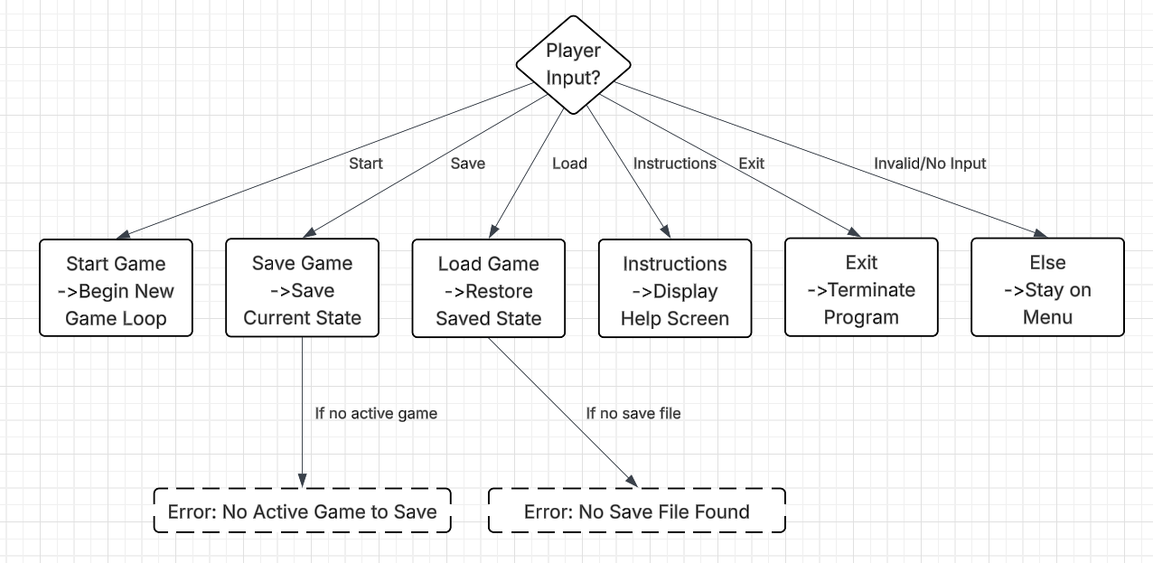

Acceptance Tests ________9

Menu Navigation Tests
- Input: Launch game → observe menu screen.
- Output: All 5 options (Start Game, Save Game, Load Game, Instructions, Exit) appear.
- Boundary Case: Test on different resolutions (720p, 1080p, 4K) → all options must still align correctly.
- Input: Arrow keys / controller joystick pressed.
- Output: Highlight moves to the correct next option.
- Boundary Case: At top option, pressing “Up” stays on top; at bottom option, pressing “Down” stays on bottom.
- Input: Enter/Confirm pressed on highlighted option.
- Output: Correct function is triggered (Start → New Game, Save → Save File, etc.).

Save/Load Tests
- Input: Select Save Game.
- Output: A valid save file is created in designated directory.
- Boundary Case: Attempt saving multiple times → newest file overwrites correctly (or creates a new slot, if designed).
- Input: Select Load Game with valid save file.
- Output: Restores game state (position, stats, progress).
- Boundary Case: Attempt load with no save file → error message appears, menu stays active.

Error Handling Tests
- Input: Invalid key/button (not mapped).
- Output: Menu ignores input, does not crash.
- Input: No input for 30 seconds.
- Output: Menu remains idle, screen stays stable.

Placement/Style Tests
- Input: Run game on different resolutions (720p, 1080p, 4K, windowed).
- Output: Menu elements scale properly without distortion.
- Input: Verify design elements (retro font, pixel-style icons).
- Output: Matches retro hockey theme.

Timeline _________/10

Work items
Task | Duration (hours) | Predecessor Task(s)
1. Menu Wireframe Design | 4 | -
2. Menu Art & Retro Styling | 6 | 1
3. Menu Navigation Logic | 5 | 1
4. Save Game Functionality | 5 | 3
5. Load Game Functionality | 5 | 4
6. Integration with Game Loop | 5 | 3,4,5
7. Error Handling and Idle State | 3 | 3
8. Testing | 4 | 6,7
9. Documentation | 3 | 8
10. Intallation/Deployment | 2 | 9

Pert diagram
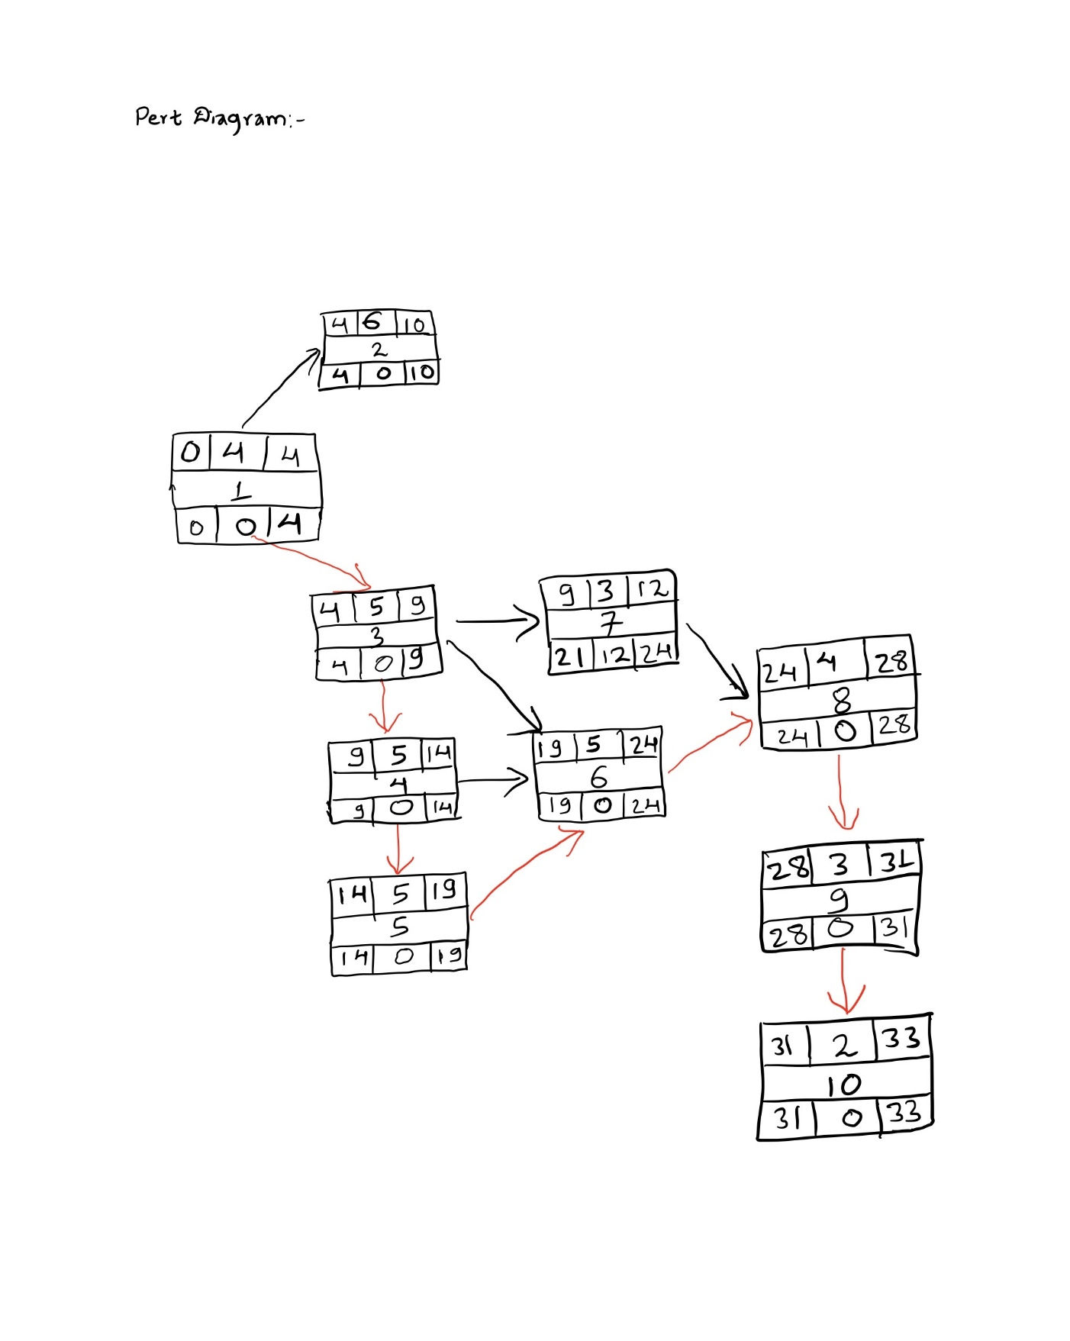

Gantt timeline
1
2 |  |  |  |  | 1
3 |  |  |  |  | 1
4 |  |  |  |  |  |  |  |  |  | 3
5 |  |  |  |  |  |  |  |  |  |  |  |  |  |  | 4
6 |  |  |  |  |  |  |  |  |  |  |  |  |  |  |  |  |  |  |  | 5
7 |  |  |  |  |  |  |  |  |  | 3
8 |  |  |  |  |  |  |  |  |  |  |  |  |  |  |  |  |  |  |  |  |  |  |  |  | 6 | 7
9 |  |  |  |  |  |  |  |  |  |  |  |  |  |  |  |  |  |  |  |  |  |  |  |  |  |  |  |  | 8
10 |  |  |  |  |  |  |  |  |  |  |  |  |  |  |  |  |  |  |  |  |  |  |  |  |  |  |  |  |  |  |  | 9
 | 1 | 2 | 3 | 4 | 5 | 6 | 7 | 8 | 9 | 10 | 11 | 12 | 13 | 14 | 15 | 16 | 17 | 18 | 19 | 20 | 21 | 22 | 23 | 24 | 25 | 26 | 27 | 28 | 29 | 30 | 31 | 32 | 33 | 34

